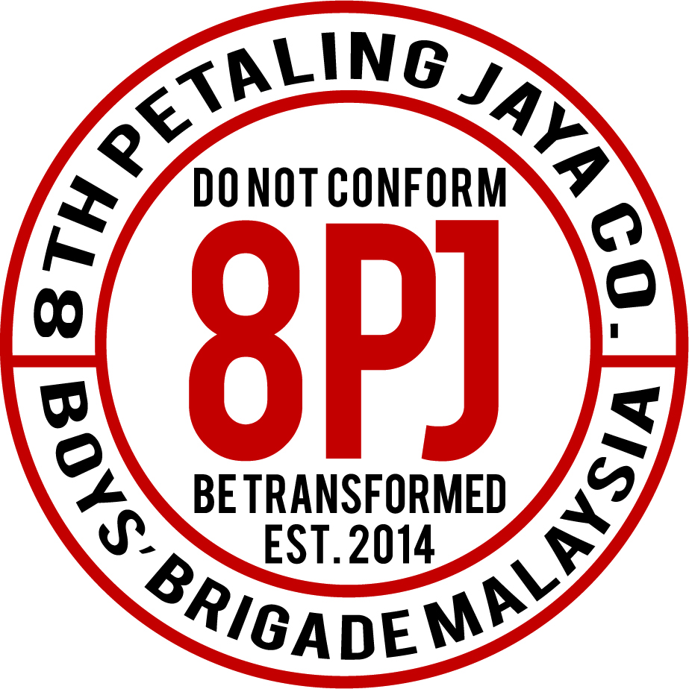
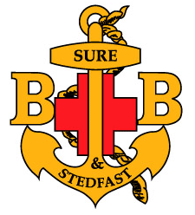
8th PETALING JAYA BOYS’ BRIGADE COMPANY
Pantai Baptist Church, No. 8, Jalan Pantai 9/7, Petaling Jaya, Selangor.

To: Senior Section Parents
From: Lt. Lee Henn
Date: 26th March 2016

RE: Citizenship Badge/Initiative Tour 2016

As part of our Citizenship badge and initiative, the whole Senior Section, including the recruits, will be taking a guided tour to the National Monument, ASEAN Exhibition, National Museum, Bank Negara’s Sasana Kijang – Museum & Art Gallery, Tunku Abdul Rahman Memorial and Dataran Merdeka.

Date: 9th April 2016 (Saturday)
Time: Assemble in PBC’s No. 8 Cafeteria by 7.15am and return to PBC by 7.00pm
Cost: RM15 (for entrance fees & bus)
RM 15-25 (for lunch at Sasana Kijang BNM) – you can pack your own lunch if you chooses to but please make sure there is no pork
Dress code: Mufti

Please kindly respond on your child’s participation for the outing by signing the consent form below and submitting it by 2nd April 2016.

Please feel free to contact us if you have any queries. Thank You.

In His service,

Lt. Lee Henn
Senior Section OIC
(012-2096256)

………………….………………………………………..……………………………………………..

RE: Citizenship Badge/Initiative Tour 2016

I consent to my child/ward participating in the above mentioned trip. I understand and accept that the 8th Petaling Jaya Boy’s Brigade Company, its Officers and its representative will not be held responsible in the event of any untoward injuries or accidents.

Name of Child : ___________________________________________________ Squad: ___________

Name of Parent: __________________________________________________

Parent’s Emergency Contact No.: _______________________________________

Child’s IC or Birth Cert No.: ______________________________________________ (for insurance)

Parent’s Signature: __________________________________ Date: ____________________________

Allergies/ Medical Condition/ Special Needs: ____________________________________________

