Worksheet 1- BB introduction
  - NCOS
1. NCOs (Non-Commissioned Officers)
- Rank 军衔:
Minimum BB Age 最低BB年龄限度:
- Rank军衔:
Minimum BB Age最低BB年龄限度:
- Rank军衔:
Minimum BB Age 最低BB年龄限度:
The qualities officers look out for in members for promotion BB 队长和军官时常观察并提升符合以下条件的队员:
(1.)
(2.)
(3.)
(4.)
(5.)

Ratio of NCO(s) to members
NCO(s) 和成员的比例_____ : ____

2. A member is discharged at the age . They may be as a by the .
成员年龄____岁将退伍。 他们也可以于____ 岁被__________ 成为一名_______________.
3. A staff sergeant is/is not a Non-Commissioned Officer (NCO). Circle the correct answer. He or she is appointed/promoted.
一名staff sergeant 是/不是 一名Non-Commissioned Officer (NCO).圈出正确的答案。他是被 任命/提拔。
4. Duties of an NCO 一名NCO的责任

5. What are the two courses of the NCO Training School? 请列出NCO训练学校的两项课程。
And

  - OFFICERS
1. Chaplain:
Colour of rosette 玫瑰花结颜色:
Colour of lanyard肩索颜色:
2. Captain:
Colour of rosette玫瑰花结颜色:
Colour of lanyard肩索颜色:
3. Honorary Captain:
Colour of rosette玫瑰花结颜色:
Colour of lanyard肩索颜色:
4. Lieutenant:
Colour of rosette玫瑰花结颜色:
Colour of lanyard肩索颜色:
5. Warrant Officer:
Colour of rosette玫瑰花结颜色:
Colour of lanyard肩索颜色:
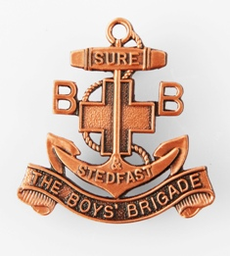
6. Badge Pins 领章

Used by被谁使用:

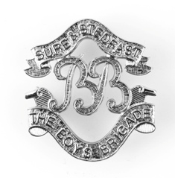
Used by 被谁使用:

7. Write down the object of the Boys Brigade写下BB的格言:

8. What are the aims, according to the object, in everyday goals for the BB Company
以下的目标能有效的将宗旨应用在男少年军分队每日的目标上 ：

9. Write down 8PJs Company Motto 写下BB8PJ的座右铭:

10. What are the twin pillars of the Boys’ Brigade 列下BB的两大柱子
And
11. What is the motto of the Boys’ Brigade 列下BB的座右铭

12. Where is the verse taken from and what is the full verse 这座右铭是从圣经的哪一篇章取出？写下完整的篇章。

13. Draw the emblem in the space below 画出BB的徽章:

14. Describe how the BB handshake is done形容BB的握手礼:

