Worksheet 7– Citizenship

The Malaysian Flag
- The National Flag of Malaysia consists of horizontal and stripes of equal , representing the in the federation of states.
- List All the 13 states:

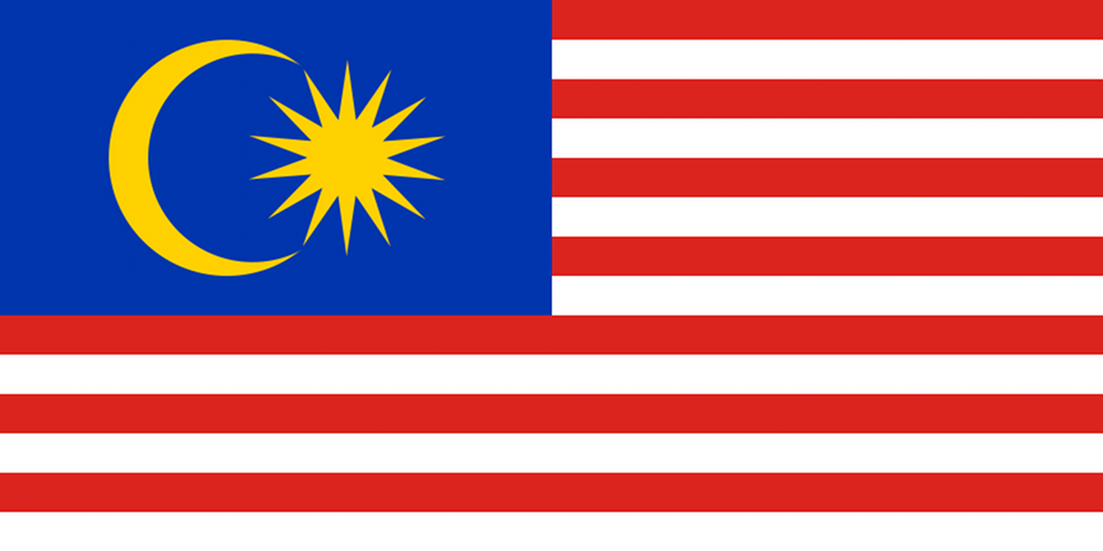
(d)
(c)
(a)
(b)

- Colour:
Represents/Meaning:

- Colour:
Represents/Meaning:

- Colour:
Represents/Meaning:

- Colours: and
Represents/Meaning:

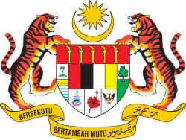
Malaysian Crest

(b)

(c)

(d)

(h)

(g)

(f)

(e)
(a)

(j)

(k)

(o)

(n)

(m)

(l)

(i)
- Name:
Represents:

- Name:
Represents:

- Name:
Represents:

- Name:
Represents:

- Name:
Represents:

- Name:
Represents:

- Name:
Represents:

- Name:
Represents:

- Name:
Represents:

- Name:
Represents:

- Name:
Represents:

- Name:
Represents:

- Name:
Represents:

- Name:
Represents:

- Name:
Represents:

National Flower
- What is the national flower called?

- Where did the flower originate from?

- What colour is Malaysia’s national flower?

- How many petals does it have?

- When was the plant introduced into Malaysia?

The Constitution

- What is the constitution of Malaysia?

- What does the constitution of Malaysia set out?

- What does the constitution guarantee?

- How can the constitution be amended?

The Parliament

- Who does the parliament comprise of?

- How many members does the Dewan Rakyat comprise of and from where do they come from?

- How long is each term of the Dewan Rakyat?

- The Dewan Negara has a membership of how many members? How many members are appointed and elected?

- How are members elected?

- Who appoints the rest of the members?

- What is the job of the Cabinet Council of Ministers? Who is it made up of? Who appoints the Cabinet Council of Ministers?

The Judiciary

- In Malaysia, where is the judicial power vested in?

- Who is the head of the Judiciary and what does it consist of?

Our Pledge (Rukun Negara)

- Why was the principles, known as the rukun negara, formed?

- Write down the rukun negara in both English and BM:

- Write out the National Anthem:

