Boys' Brigade Workbook
for PINK Badge
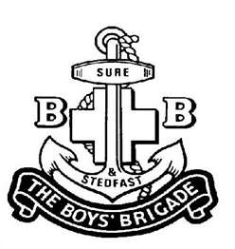
8th Petaling Jaya Company

Name :
Squad :
Age :
Year :____________________

This document lists the some of lessons which 8PJ prejunior section members will go through to receive Pink Badge Award. To achieve the Pink Badge Award, members have to meet below requirements:-

- Pass an oral test based on lessons taught in this workbook
- Pass drill test listed in workbook
- Achieve a 70% attendance (absence will be considered present with leave application approved by section OIC)
- Compliance to company rules and regulations
Lesson 1

The Badge
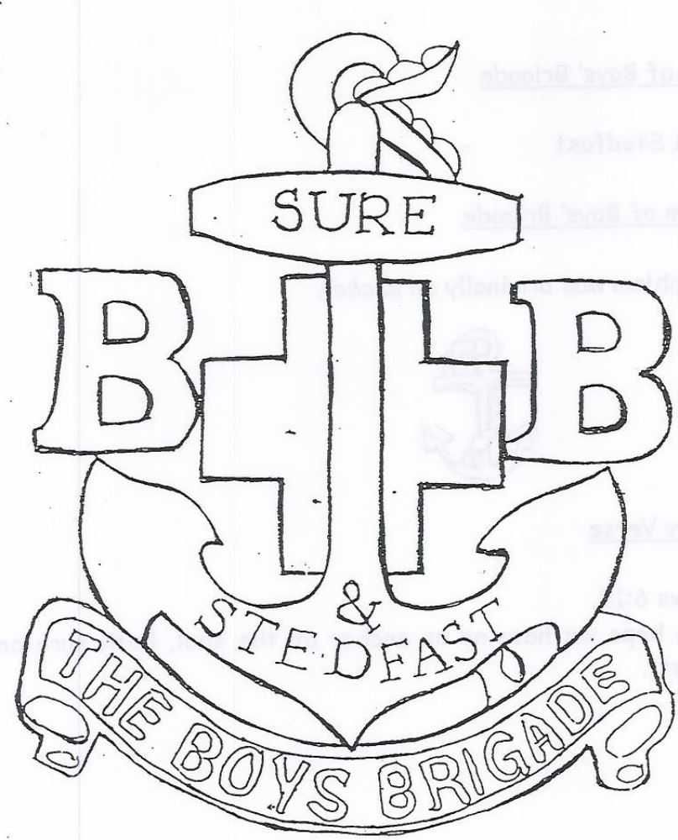
Colour the badge

Lesson 2
(A) History of Boys' Brigade
- The Boys' Brigade was founded on 4th of October 1883.
- The founder of Boys' Brigade was Sir William Alexander Smith.

(B) Motto of Boys' Brigade
Sure & Stedfast

(C) Emblem of Boys' Brigade
The emblem was originally an anchor.
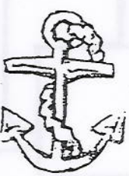

(D) Memory Verse
Hebrews 6:19
“Which hope we have as anchor of the soul, both sure and stedfast.”

(E) Captain of my Company
The Captain of 8th PJ Company in year
is Captain .

Worksheet 2
- The Boys' Brigade was founded on
- 4th of October 1983
- 4th of October 1883
2. The founder of Boys' Brigade was
- Sir Alexander William Smith
- Sir William Alexander Smith
- The motto of Boys' Brigade is
- Sure and Stedfast
- Hope and Anchor
4. The original Emblem of the Boys' Brigade was
Please tick ( √ ) :
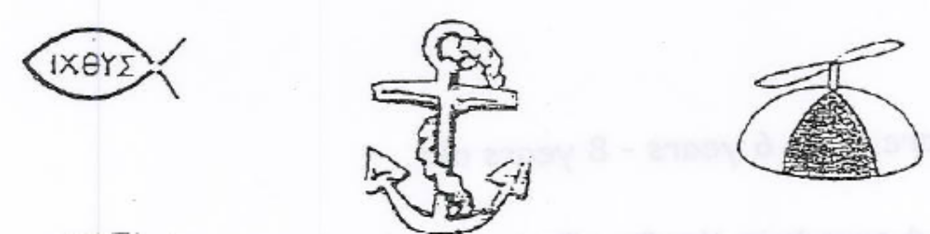

- Hebrews 6:19
“Which we have as an of the

both and .”

Lesson 3

Our Boys' Brigade Company
Company Name : BB8 PJ (8th Petaling Jaya)
Composition : 3 Sections
We are the : Pre-Juniors Section
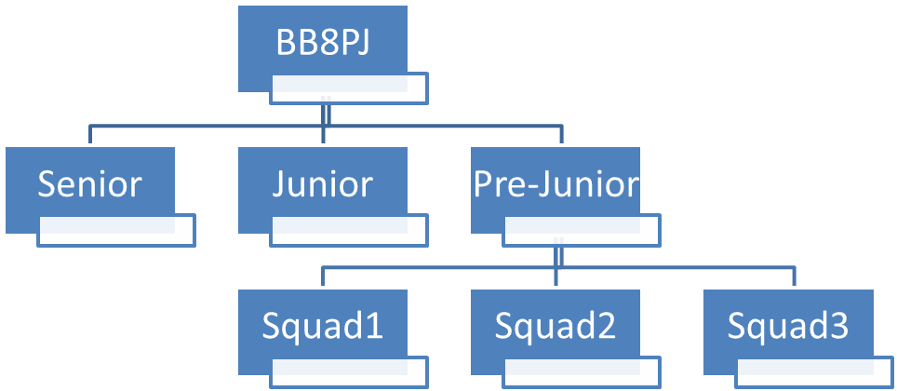
Pre-Juniors
- Members are from 6 years to 8 years old.
- There are squads in the Pre-Junior Section.
- We have 1 Officer-In Charge (OIC) and 1 Assistant Officer-In Charge (AOIC)

Worksheet 3
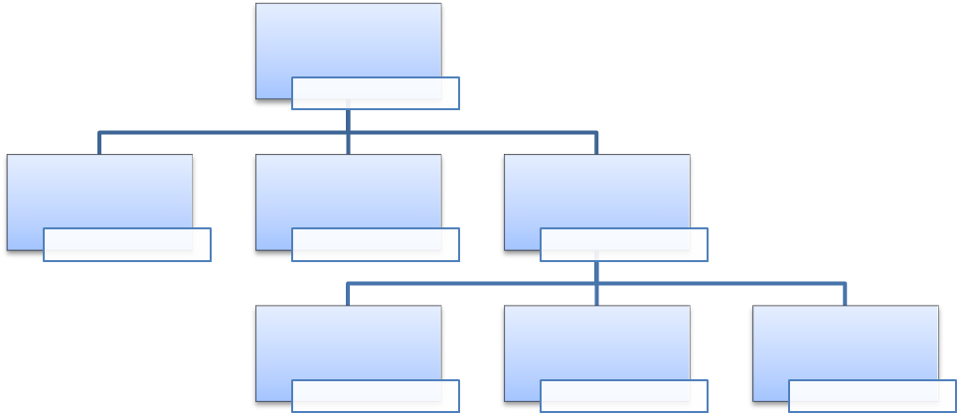
    - Our company is __________________________________
    - We have _______ sections.
We are members of the ___________________ section
    - There are ______ squads in the Pre-Juniors Section.
    - We have __________members;
_________boys and ________girls.
    - Our OIC is _______________________
    - Our AOIC is ______________________

Lesson 4

BB UNIFORM
- Every member should be proud of the BB uniform
- Members must take care of their uniform and ensure that it is
  - clean
  - neat
  - tidy
- No part of uniform shall be worn or removed in public viewing and while in uniform.
- No dyeing of hair, body ornaments or decorations or badges are permitted except for those allowed by BB regulations.

Pre-Junior Section Day Dress:

- Field Service Cap with Cap Badge

- Navy blue collar T-shirt with Junior Section Crest on the left side.

- Name tag
- For boys – white background with black wordings
- For girls – blue background with white wordings

- Navy blue shorts with 2 side pockets and belt loop

- One inch BB white belt

- Navy blue long socks are pulled up all the way to just below the knee

- Black canvas shoes

- Badges are to be worn on the right hand sleeve laterally and 3 fingers below the shoulder flash.

Worksheet 4

BB Prejunior Section Day Dress
Match the uniform parts

Description | Match line | Uniform Parts Picture
White BB belt |  | 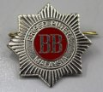
Navy blue shorts |  | 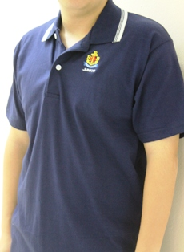
Navy blue collar T-shirt with Junior Section Crest on the left side |  | 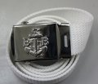
Field Service Cap with Cap Badge |  | 
Navy blue long socks |  | 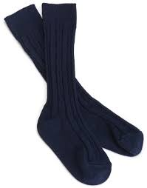
Name tags |  | 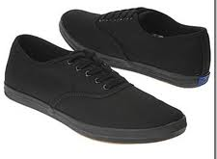
Black Canvas Shoes |  | 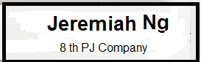

Lesson 5
BB VESPER

▪ The BB Vesper is a prayer that we sing at the end of a BB parade, gathering or function
▪ Every BB Officer and member is expected to know how to sing it.

GREAT God, Who knowest all our need,
Bless Thou our watch, and guard our sleep;
Forgive our sins of thought and deed,
And in Thy peace Thy servants keep.

We Thank Thee for the day that’s done
We trust Thee for the days to be;
Thy love we learn in Christ Thy Son,
O may we all His glory see! Amen

ANCHOR SONG

▪ The Anchor Song promotes the “BB Spirit” and some Company sang it during the opening parade and on the first parade of every month during company fall-in.

There’s an emblem fair that is known to all
A sign to help us through
It stands for strength and it stands for right
An Anchor tried and true.

The Emblem of The Boys’ Brigade
It helps us on our way,
Our father’s knew in days gone by
This sign we know today
Sure and Stedfast
The Brigade Boys’ motto clear

That’s our watchword when trouble and trials are near
Sure and Stedfast
to the flag that flies above
In all that we do
We’ll try to be true
To the anchor that we love.

TABLE GRACE

▪ BB has a unique way of saying grace before every meal; thanking God for the food He has provided. Hence, Table Grace is sung before we eat our meal and everyone stands at attention.

Be present at our table, Lord;
Be here and everywhere adored;
Thy creatures bless, and grant that we
May feast in fellowship with Thee. Amen.

Lesson 6
PAYING COMPLIMENTS
- Generally, BB members who are in uniform will come to attention and use “Sir” or “Madam” when addressing or being addressed by an Officer.
- They will also pay the same compliments to Officers of other Companies as to their own Officers.
- Members can only salute when they are in full uniform i.e. wearing the field service cap however, members do not salute other members.
- Members need to salute the same officer only once a day with the exception if the member is receiving his/her award. At other times, greet or show respect to officer when officer is near.

 | Member | Officer | What to do
1 | Members  - full uniform  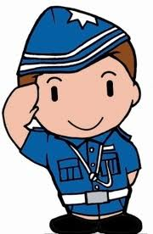 | Officer  - full uniform | - Salute and greet the officer “Good Morning/Afternoon Sir/Madam”.  - Salute until the officer puts down his/her hand first  - Member shall take a right turn and march off (KELUAR BARIS) after the officer excuses the member
2 | Members  - full uniform | Officer  - no glengarry | - Salute and greet the officer “Good Morning/Afternoon Sir/Madam”.  - Salute until the officer gives a nod or a sign of approval  - Member shall take a right turn and march off (KELUAR BARIS) after the officer excuses the member
3 | Members  - not wearing a cap  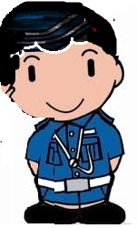 | Officer  - full uniform | - Stand at attention facing the officer and greet the officer “Good Morning/ Afternoon Sir/Madam”.
4 | Two or more members are together in uniform | Officer  - full uniform | - The most senior member will face the officer.  - Call the rest of party to attention  - The most senior member alone will salute.

Section B. DRILL Commands – Pink Badge

A | Drill Commands |  |  | Position | Description
1 | Sedia  ATTENTION |  | 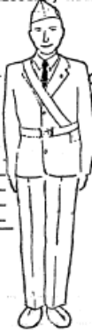  The position is one of readiness in expectation of further commands. |  | - Heels together and in line;  - feet turned out at an angle of 30 degrees;  - legs straight;  - arms straight  - hands clenched,  - head and eyes facing the front;
 |  |  | 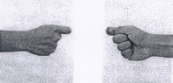 |  | Clenched Hand:  - The thumb pointing straight with the fore finger in line with the thumb followed by enclosing the thumb
2 | Senang Diri  STAND AT—EASE |  | 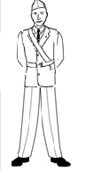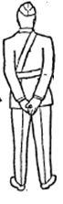  Lift Left leg, PAUSE – SATU  Hentak – DUA |  | FROM SEDIA position  - Keeping the legs straight, the left foot is moved 15cm (6 inches),  measured from heel to heel,  - The hands are placed behind the back, with the arms fully extended,  - The back of the right hand placed in the palm of the left, with fingers of both hands straight, and thumbs crossed.
3 | Rehatkan Diri  STAND—EASY |  | 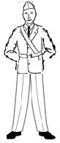  PAUSE – SATU, DUA, TIGA  Bend arms to final position – SATU |  | FROM Senang DIRI position  - Maintain position as Senang Diri but elbows are now bent so that the hands reach the belt
4 | Squad |  | Straighten arms to final position – SATU |  | FROM Rehat DIRI position  - At this command, “SQUAD,the arms are straightened and the Senang DIRI position resumed.  .
5 | Squad Sedia |  | Lift left leg and arms to sides – SATU  Stamp left foot on ground – DUA |  | FROM Senang DIRI position  - The left foot is brought up to the right without stamping, and the position of Sedia is resumed.
6 | Keluar Baris  FALL—OUT | 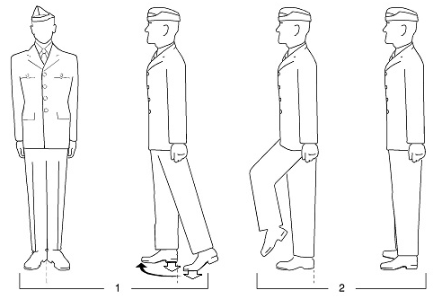 |  |  | Turns to the right and march off three paces
TURN : PAUSE: HENTAK:
SATU DUA SATU

Pause – DUA, TIGA
March – SATU, DUA, TIGA

12 | BB Hand-shake | 

